**Required Hardware for Prototype Function**

**Basic Function**

The most basic function of the design is to compress a clothing water mixture in a chamber which has a capacity to hold only the clothing and water contained in it (no other fluids or materials). Fluid displaced in this process is moved into a reservoir created by the space behind the piston during compression, or out of the washing machine depending on the phase of the wash process. The reasoning for this design is covered in 2: General Method Justification. Covered in this document are the components that are required to make this possible.

**Compression**

***A note about the purpose and function of compression:***

*The key idea of this design is fluid flow rather than fluid pressure. To illustrate this point, think of a clothing item as a spring and consider the fluid occupying the space around it. While a spring can be compressed with great force, the fluid in the space around it is not necessarily at a high pressure. Such is the case for the washing machine. As the shirt is compressed, the wash chamber size is reduced, displacing the fluid in the chamber and forcing it to flow through the pipes into the reservoir.*

*Possible sources of fluid pressure:*

* *Though the piston will be moving slowly, flow of fluid out of the chamber through the small pipes that make up the system may result in pressure in the wash chamber as fluid can only enter the plumbing at a given rate.*
* *Much like in the first point, fluid being pushed through the clothing item will have its flow significantly impeded by the clothing item, if the rate of fluid evacuation is not high enough to match the rate of displacement, the fluid will produce a reaction force to match the compression of the piston head.*
* *As will be discussed later in this document, though the wash chamber and reservoir are ideally constant in size, it actually fluctuates in size. Because of this, fluid will be doing work against the chamber top as it counteracts the spring force holding the chamber top in place.*

*All this being said, pressure in the chamber should not exceed the force being applied by the piston head divided by the area of the piston head, as no other forces should be acting on the fluid.*

**Force Application:**

[[CAD Picture]]

Method of Force Application: In order to compress a clothing item, a linear force needs to act on the piston head to compress the clothing item. A rod extending through the chamber top and out of the chamber is connected to a piece of machinery that will supply this force. This force could be applied using a number of different methods such as linear actuators, hydraulics, pneumatics, and other means, but the one used for this machine will be several threaded rods engaging with a base attached to the shaft. This design is similar to that of a linear actuator, taking an electric force and turning it into a rotational force via a motor, and then using that to drive a screw, creating a linear force to ack on the clothing. The key difference is that a linear actuator takes up more linear space, where this method has the potential to have the needed hardware placed around the wash chamber where the space isn’t being used anyways. This acting base is constrained to the frame such that only vertical movement is allowed. The threaded rods will be rotated by a drive train, where a single electric motor will drive a belt or chain attached to a gear on each of the threaded rods. As will be expanded upon later, the chamber top also needs to be made moveable, and thus will require a similar force application method of its own.

Advantages of Threaded Rod and Drive Train Force Application Method: The importance of this system is that it is driven by an electric power source, and aside from the driving base attached to the piston arm, all hardware required to drive the force application can be placed alongside the wash chamber rather than above it, which helps to maximize the allowable piston head travel. Additionally, a mechanical system reduces complexity when compared to hydraulic or pneumatic systems that can generate excessive vibrations and noise, while also coming with risk of leaking, which can pose a great threat in microgravity.

**Bearings:**

[[CAD Picture]]

Since force is generated through the use of rotating rods, it is important that these rods are properly constrained such that they effectively apply the force required to the piston head, and transfer reaction forces into the frame such that the system remains static. Since the only degree of freedom desired for the threaded rods is rotating about its length, both axial bearings, also called thrust bearings, and radial load bearings will be used.

Radial Bearing Location: At either end of the threaded rods, a radial load bearing will be used to counteract forces perpendicular to the rod. This will keep the rods from rotating along any axis other than the vertical one along their length. These radial bearings will also be used on either side of the chain ring transferring the force of the motor to the threaded rods. This will prevent bending of the threaded rods at the chain rings, and make for efficient energy transfer.

Axial Bearing Location: With all movement not along the axis of rotation being inhibited by the radial bearings, the only motion still allowed for the threaded rods is linear motion along the axis of rotation. To inhibit this movement and transfer the force into the piston shaft, thrust bearings are put at either end of the threaded rods, after the radial bearing. These bearings are put at both ends so that the rods remain in tension no matter which direction the rods are rotated. This is done to simplify the design, as well as reduce the need for bearings, as the threaded rods cannot bend under tension force

Bearings in the Drive Train System: While the threaded rods need to be constrained with bearings, this is not the only place where bearings are required. At the location of force application, the motor connection to the drive train, a gear on a shaft interfaces with the chain. Here, two axial bearings are placed on either side of the gear to prevent forces or rotation as a result of the reaction forces of the chain on the gear.

**Additional Constraints on Drive Train System:**

The motor also needs to be constrained so that it does not spin itself with the presence of a load. To do this, the motor is bolted to a segment of the frame.

**Sensing:**

On the drive train, it is important for automation and diagnostics that the position of the acting base and piston head as well as the force being applied by the piston head. The location of the piston head is found using a potentiometer, which will measure the rotation of one of the threaded rods. Since the rotation of the threaded rods is directly proportional to the position of the piston head, the rotation can be used to calculate the position of the piston head. The force being applied will be measured using a load cell attached to the shaft and acting base. The load cell must be along the shaft because that is where the force is being applied linearly.

**Fluid Control**

***Overview:***

*The whole purpose of sealing the piston head against the chamber wall is to allow for control over where fluid goes when forced out of the wash chamber. Plumbing is used as a channel for fluid to flow through, and valves are used to direct this flow in a desired manner.*

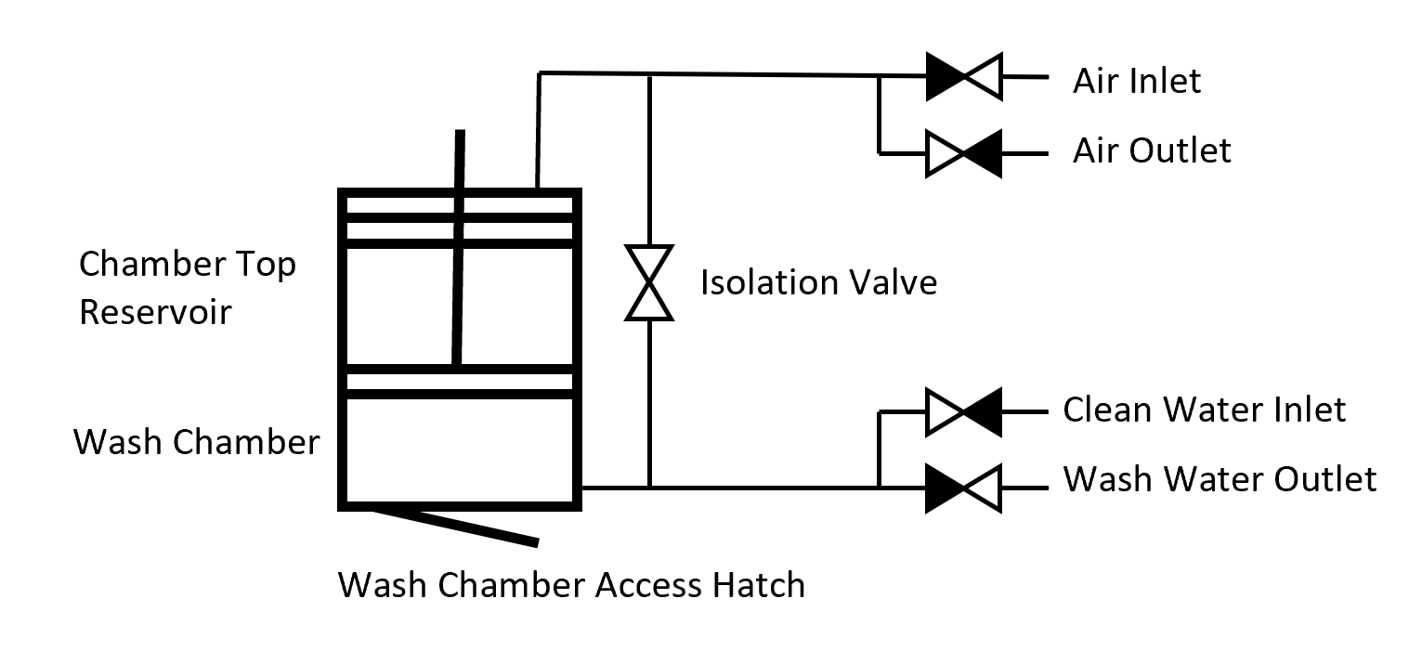

**Piping:**

Piping is used to allow flow from one area to another. In order for fluid to be able to flow from the wash chamber to the reservoir, a pipe connects these spaces. This pipe connects to these spaces as close to the bottom of the wash chamber as possible and on the top of the chamber top to allow as much movement of the piston head as possible. This is an important aspect of the connection since if the linear seals of the acting piston pass the openings created by these pipes, fluid can no longer flow out of these chambers. Since the chamber top is made to move, the pipe connection needs to be able to accommodate for this movement while maintaining a sealed connection.

Now that the connection between the chamber top and wash chamber is established, the fluid inlets and outlets can be established. Closest to the wash chamber, a T is made in the connecting pipe. This extension will T off and accommodate the clean water inlet and dirty water outlet. Finally, closest to the side of the reservoir there will be a T which will accommodate access to the atmosphere, where displaced air will be vented. These inlets and outlets enable the washing machine to control the occupying fluid type within each of the chambers while maintaining a constant volume and pressure.

**Control Valves:**

While piping allows the flow of various fluids in the washing machine, valves control the flow of these fluids. In order to allow all functions needed for the wash process, valves are placed at each of the inlets and outlets as well as on the pipe connecting the chamber top and wash chamber, called the isolation valve. It is important that the isolation valve is between the T for water access, and the T for air access.

**Wash Chamber Functions**

**Maintaining a Constant Chamber Volume During Compression:**

For simplicity, let's look at the wash chamber and reservoir as one chamber and ignore sealing on the piston. While moving a mass such as a piston head in a closed container cannot change the fluid volume in the container, the shaft acting on the piston head needs to protrude into the container in order to move it, which will reduce the holding capacity of the chamber. Because of this, the further the shaft has to extend into the chamber, the less volume that container will be able to hold. This is a big problem because water, being incompressible, will lock up the system and keep compression from being possible without a failure somewhere in the system. In order to hold a constant volume in the wash chamber, the reservoir needs to be able to change size and accommodate for this change in fluid volume. In order to do this, the chamber top is made to move with a min and max constraint on vertical movement. The chamber top should work to ensure the minimal allowable volume is in the chamber, so a spring will be used to push the chamber top in so that it will not allow for a greater fluid capacity without the fluid in the chamber actually acting on it.

**Accommodating Clothing of Different Volumes:**

When the design is expanded upon to accommodate other types and sizes of clothing, it is important that the wash chamber, though constant in fluid capacity during the wash process, can vary in capacity such that clothing with a greater volume, or more or less volume is used. Since the size of the chamber is directly affected by the position of the chamber top, a similar actuation method the that of the piston head will be added to allow for movement and control over the chamber top position.

**Sealing:**

Sealing is an essential part of any machine where fluids are involved. It is important that any component connected to the wash chamber has a gasket or other seal to ensure minimal leakage. Since the wash chamber is a 4 inch piece of pvc pipe clamped between an upper and lower frame base, a seal is needed on the pipe against the chamber top and lower frame base. Sealing at the chamber top is done by the chamber top, a piston of sorts that seals the pipe, as well as the piston shaft using linear seals. The chamber bottom is sealed by a gasket

**Accessing Clothing:**

The washing machine needs a way for an astronaut to access, add and remove their clothing from the wash chamber. With the bottom frame base being the only flat surface without any interfering components to the rest of the machine, and being the actual outside of the machine, and being the closest point of the wash chamber to the outside, the bottom frame base is the optimal place for an access hatch. The access hatch is formed by a hole in the frame base, to which a sealed hatch is hinged to such that an astronaut can manually open and close the hatch as needed.

**Structural Components**

**Base Frames**

The entire wash structure needs to be made to handle the reactionary forces from compression. Moments generated across the base frames will result in bending stress. This is determined in large part by the thickness of the base frame and applied force. Since the washing machine needs to be as short as possible along its height, finding the minimal base thickness to handle the applied force of the applied force of th piston is extremely important. These frames also house bearings, couplings with other structural components, and need holes in them to prevent interference with other components or allow access to various parts of the washing machine. All of these factors also go into determining the required geometry and thickness of the plates.

**Other Structural Frames**

Bearings at the drive train and motor require additional structural bases to counter moments and horizontal forces that would otherwise result in components rotating uncontrollably or moving around in the machine unconstrained. This requires an additional frame base between the lower and middle frame base.

**Structural Beams:**

These components are rigid and must handle compressive and tensile loads as well as resist moments generated by the applied forces of the machine and resulting bending of components. These beams along with the base plates form the superstructure of the washing machine. It is important that a construction is found that can handle the applied forces, while being as thin as possible to allow space for the other components such as the drive train, electronics, and plumbing.

**Cross Braces:**

Ideally there are no horizontal forces acting across the washing machine frame, but countering moments of the driving motor, forces generated by the threaded rods on the ball bearings, and buckling forces means that horizontal forces need to be accounted for and dealt with. These are members that diagonally reinforce the structural beams so that horizontal forces across the machine can be counteracted and structural stability can be maintained.

**Safety Components**

A lot of safety components in the design will be components of software Some of the goals of these components might ensure:

* Too much current is not going through electronic components
* Ensuring there are no leaks in the system, and detecting possible leaks
* Ensuring force capable of damaging clothing or other components is not generated by the applied linear force of the drivetrain
* Detecting mechanical failure and stopping the machine in the case of detection
* User controlled emergency stop

These can be detected and controlled by various means in hardware and software. Having multiple redundant systems to detect problems and stop the system accordingly.

**Electronic Components**

**12V DC Components:**

Actuation and Physical Control:

2 Motors: One drives acting piston, the other moves the piston top

4 Electronically Actuated Valves: Control the flow of fluid in the system

Sensing/Safety/Control:

1 Load Cell: Could also be 5 volts. Measures force applied by acting piston

5 Relays: Powered at 12 volts. Takes 5 volt control voltage to control 12 Volt Components

1 Arduino Microcontroller: Reads sensing and controls system. Inputs/Outputs 5 volt signal

12 Volt Breaker: Will break the circuit if power consumption endangers electronic components

**5V DC Components:**

Sensing/Safety/Control:

2 Potentiometers: Uses rotation of threaded rods to determine piston position

1 SD Card Reader/Writer: Saves sensor values and wash state to be read back after process

1 HXS711: Takes output signal of Load Cell to be read by Arduino

1 Amperage Sensor: Measure power consumption and serve as additional safety component